**Group Number:** C1-027  
**Repository:** https://github.com/DP2-C1-027/AirNav-Logistics  
**Members:**

* **Garcia de Tejada Delgado, Jose**
  + Role: Developer
  + Email: josgardel8@alum.us.es
* **Peñaloza Friqui, Nora**
  + Role: Developer
  + Email: norpennfri@alum.us.es
* **Niza Cobo, Manuel Jesús**
  + Role: Manager, Developer
  + Email: mannizcob@alum.us.es
* **Gomez Claraco, Nicolas**
  + Role: Developer
  + Email: nicgomcla@alum.us.es
* **Campos Diez, Lucia**
  + Role: Tester, Developer
  + Email: [luccamdie@alum.us.es](mailto:luccamdie@alum.us.es)

**Date:** 19-02-2025

**Table of Contents**

1. Executive Summary
2. Revision Table
3. Introduction
4. Planning Chapter
   * Task Listing
   * Screenshots of Development Phases
   * Budget Estimation
5. Progress Chapter
   * Progress Records
   * Conflict Resolution
   * Cost Comparison
6. Conclusions
7. Bibliography

**Executive Summary**

This report details the planning and progress of our project deliverable, structured into two main sections: planning and progress. The planning chapter outlines task allocation, estimated efforts, screenshots of development phases, and budget estimations. The progress chapter provides performance records, conflict resolution approaches, and a cost comparison between the estimated and actual expenditures. This document ensures compliance with the project’s working methodology and best practices.

**Revision Table**

|  |  |  |
| --- | --- | --- |
| **Revision Number** | **Date** | **Description of Changes** |
| 1.0 | 10-02-2025 | Initial Draft |
| 1.1 | 14-02-2025 | Updated Cost Estimation |
| 1.2 | 20-02-2025 | Final Version |
| 1.3 | 13-03-2025 | Added new entries for deliverable D02 |

**Introduction**

This document presents a structured report on the planning and progress of the project deliverable. It is divided into two main sections: the planning chapter, which includes task breakdown, screenshots from the project management tool, and budget estimation; and the progress chapter, which documents workgroup performance, conflict resolution, and a final cost comparison. The document follows a professional yet simple styling to ensure clarity and readability.

**Planning Chapter**

**Task Listing**

|  |  |  |  |  |  |
| --- | --- | --- | --- | --- | --- |
| Task | Description | Assignee | Role | Planned Time | Actual Time |
| Modify the anonymous menu | The anonymous menu was modified to display an option that redirects the browser to the homepage of a favorite website, with the title formatted as: “〈id-number〉: 〈surname〉, 〈name〉” | Nora Peñaloza | Developer | 30 minutes | 15 minutes |
| Provide a link to the GitHub planning dashboard | A link was provided to the planning dashboard for reviewing the task statuses and project schedule. | Nora Peñaloza | Developer | 30 minutes | 10 minutes |
| Planning and Progress Report | Created the planning and progress report with all the required details. | Nora Peñaloza | Developer | 3 hours | 5 hours |
| Analysis Report | Produced the analysis report with the corresponding logs. | Nora Peñaloza | Developer | 3 hours | 1 hours |
| Set up the workspace | Configured the workspace for the project. | Nora Peñaloza | Developer | 1.5 hours | 5 hours |
| Attend classes | Attended 6 classes (5 theory class and 1 follow-up), each lasting 1.5 hours | Nora Peñaloza | Developer | 9 hours | 9 hours |
| Recruiment Meeting | A post was made in the forum by the manager and i responded expressing my interest in joining the group. | Nora Peñaloza | Developer | 30 minutes | 5 minutes |
| Edit text files | Edited the changelog, contributors, license, and readme files of the repository to keep documentation up-to-date. | Nora Peñaloza | Developer | 2 hours | 1.5 hours |
| Report on WIS Testing | Created a report on the tests conducted on the WIS system. | Nora Peñaloza | Developer | 2 hours | 2 hours |
| Meeting1 | First meeting where we expressed our expectations regarding the work and the selection of the manager. | Nora Peñaloza | Developer | 1.5 hours | 1 hour |
| Meeting 2 | We share our progress and improvements for the first deliverable | Nora Peñaloza | Developer | 40 minutes | 1 hour |
| Modify the anonymous menu | The anonymous menu was modified to display an option that redirects the browser to the homepage of a favorite website, with the title formatted as: “〈id-number〉: 〈surname〉, 〈name〉” | Nicolás Gómez | Developer | 30 minutes | 20 minutes |
| Provide a link to the GitHub planning dashboard | A link was provided to the planning dashboard for reviewing the task statuses and project schedule. | Nicolás Gómez | Developer | 30 minutes | 5 minutes |
| Planning and Progress Report | Created the planning and progress report with all the required details. | Nicolás Gómez | Developer | 2 hours | 4 hours |
| Set up the workspace | Configured the workspace for the project | Nicolás Gómez | Developer | 3 hours | 2 hours |
| Attend classes | Attended 6 classes (5 theory class and 1 follow-up), each lasting 2 hours | Nicolás Gómez | Developer | 12 hours | 12 hours |
| Change Banner Text, Banner, Logo, and Favicon | Update branding elements, including text, logo, and favicon. Simple UI change with minimal impact on code structure. | Nicolás Gómez | Developer | 2 hours | 1.5 hours |
| Customize the Fragments (Banner, Footer, Company, etc.) | Modify standard UI components to align with project branding. Required adjustments to UI component files with no major structural changes. | Nicolás Gómez | Developer | 2 hours | 4 hours |
| Modify the anonymous menu | The anonymous menu was modified to display an option that redirects the browser to the homepage of a favorite website, with the title formatted as: “〈id-number〉: 〈surname〉, 〈name〉” | Lucía Campos | Developer | 35 minutes | 20 minutes |
| Provide a link to the GitHub planning dashboard | A link was provided to the planning dashboard for reviewing the task statuses and project schedule. | Lucía Campos | Developer | 20 minutes | 5 minutes |
| Planning and Progress Report | Created the planning and progress report with all the required details. | Lucía Campos | Developer | 3 hours | 4 hours |
| Analysis Report | Produced the analysis report with the corresponding logs. | Lucía Campos | Developer | 3 hours | 2 hours |
| Set up the workspace | Configured the workspace for the project. | Lucía Campos | Developer | 1.5 hours | 5.5 hours |
| Attend classes | Attended 6 classes (5 theory class and 1 follow-up), each lasting 1.5 hours | Lucía Campos | Developer | 9 hours | 9 hours |
| Report on how you have set up your development configuration | Created a report on how you have set up your development configuration. | Lucía Campos | Developer | 2 hours | 2.5 hours |
| Planning and progress group report | Created the planning and progress group report with all the required details. | Lucía Campos | Developer | 3 hours | 4.5 hours |
| Meeting1 | First meeting where we expressed our expectations regarding the work and the selection of the manager. | Lucía Campos | Developer | 1.5 hours | 1 hour |
| Meeting 2 | We share our progress and improvements for the first deliverable | Lucía Campos | Developer | 40 minutes | 1 hour |
| Modify the anonymous menu | The anonymous menu was modified to display an option that redirects the browser to the homepage of a favorite | José García de Tejada | Developer | 10 minutes | 5 minutes |
| Provide a link to the GitHub planning dashboard | A link was provided to the planning dashboard for reviewing the task statuses and project schedule. | José García de Tejada | Developer | 15 minutes | 15 minutes |
| Planning and Progress Report | Created the planning and progress report with all the required details. | José García de Tejada | Developer | 2 hours | 1 hour 30 minutes |
| Analysis report | Produced the analysis report with the corresponding logs. | José García de Tejada | Developer | 2 hours | 2 hours |
| Attend classes | Attended 6 DP2 classes as part of training and preparation for the realization of the project | José García de Tejada | Developer | 12 hours | 12 hours |
| Set up the workspace | Configured the workspace for the project. | José García de Tejada | Developer | 1.5 hours | 3 hours |
| First meeting | First meeting where we expressed our expectations regarding the work and the selection of the manager. | José García de Tejada | Developer | 1 hour | 1 hour |
| Second meeting | We share our progress and improvements for the first deliverable | José García de Tejada | Developer | 1 hour | 1 hour |
| Group report on previous knowledge about WIS | Produced a report on previous knowledge of Web Information Systems | José García de Tejada | Developer | 1 hour | 1 hour 30 minutes |
| Modify the anonymous menu | The anonymous menu was modified to display an option that redirects the browser to the homepage of a favorite website, with the title formatted as: “〈id-number〉: 〈surname〉, 〈name〉” | Manuel Jesús Niza | Developer | 30 minutes | 15 minutes |
| Provide a link to the GitHub planning dashboard | A link was provided to the planning dashboard for reviewing the task statuses and project schedule. | Manuel Jesús Niza | Developer | 30 minutes | 10 minutes |
| Planning and Progress Report (Individual) | Created the planning and progress report with all the required details. | Manuel Jesús Niza | Developer | 3 hours | 5 hours |
| Analysis Report  (Individual) | Produced the analysis report with the corresponding logs. | Manuel Jesús Niza | Developer | 2 hours | 1 hours |
| Set up the workspace | Configured the workspace for the project. | Manuel Jesús Niza | Developer | 2 hours | 2 hours |
| Set up the github project and the dashboard | Configure and set the actual project in github and the dashboard with the tasks. | Manuel Jesús Niza | Manager | 2 hours | 2 hours |
| Attend classes | Attended 6 classes (5 theory class and 1 follow-up), each lasting 1.5 hours | Manuel Jesús Niza | Developer | 9 hours | 9 hours |
| Split tasks with the team | Split all the tasks with each member of the team | Manuel Jesús Niza | Manager | 30 minutes | 15 minutes |
| Recruiment Meeting | A post was made in the forum and did a meeting with Nora. | Manuel Jesús Niza | Manager | 30 minutes | 5 minutes |
| Analysis Report  (Group) | Created an analysis report based on the most important requirements. | Manuel Jesús Niza | Developer | 2 hours | 1 hours |
| Meeting1 | First meeting where we expressed our expectations regarding the work and the selection of the manager. | Manuel Jesús Niza | Manager | 1 hour | 1 hour |
| Meeting 2 | We share our progress and improvements for the first deliverable | Manuel Jesús Niza | Manager | 1 hour | 1 hour |

|  |  |  |  |  |  |
| --- | --- | --- | --- | --- | --- |
| Task | Description | Assignee | Role | Planned Time | Actual Time |
| Customers data model | task involves designing and implementing a structured model to store and manage customer-related data | Nora Peñaloza | Developer | 1 hour | 30 minutes |
| Booking data model | task involves designing and implementing a structured model to store and manage booking-related data | Nora Peñaloza | Developer | 1 hour | 30 minutes |
| Passenger data model | task involves designing and implementing a structured model to store and manage passenger-related data | Nora Peñaloza | Developer | 1 hour | 30 minutes |
| Produce customer data | task involves creating a sufficient number of sample entries in CSV files to support informal testing of the application | Nora Peñaloza | Developer | 1 hour | 3 hours |
| Provide a link to the GitHub planning dashboard | A link was provided to the planning dashboard for reviewing the task statuses and project schedule. | Nora Peñaloza | Developer | 30 minutes | 10 minutes |
| Customers dashboard | task involves designing and implementing a system related to customer activity on a personalized dashboard. | Nora Peñaloza | Developer | 2 hours | 1 hours |
| UML (individual) | The task involves designing a uml diagram that represents all entities and their relationships within the system | Nora Peñaloza | Developer | 30 minutes | 2 hours |
| Recommendations board | task involves implementing a feature that provides personalized recommendations for experiences, activities, restaurants, accommodations, and other interesting things for users visiting a specific airport's city or country. | Nora Peñaloza | Developer | 2 hours | 1 hour |
| Attend classes | Attended 5 classes (3 theory class and 2 follow-up), each lasting 1.5 hours. | Nora Peñaloza | Developer | 7.5 hours | 7.5 hours |
| Update the workspace | Configured the workspace for the project with the last update | Nora Peñaloza | Developer | 1.5 hours | 30 minutes |
| Planning and Progress Report | Created the planning and progress report with all the required details. | Nora Peñaloza | Developer | 3 hours | 3 hours |
| Analysis Report | Produced the analysis report with the corresponding logs | Nora Peñaloza | Developer | 3 hours | 3 hours |
| Meeting 3 | We share our progress and improvements for the second deliverable | Nora Peñaloza | Developer | 1 hour | 1 hour |
| Meeting 4 | We share our progress and improvements for the second deliverable | Nora Peñaloza | Developer | 1 hour | 1 hour |
| UML | The task involves designing a uml diagram that represents all entities and their relationships within the system. | Nora Peñaloza | Developer | 1 hour | 3 hours |
| Airport data model | task involves designing and implementing a structured model to store and manage passenger-related data | Nora Peñaloza | Developer | 1 hour | 30 minutes |
| Assistance Agent Claims and Tracking Logs Data Model | Developed the data model for assistance agents, including fields such as employee code (with regex validation), spoken languages... Also implemented the data models for passenger claims and tracking logs, including fields like registration …. | Nicolás Gómez | Developer | 4 hours | 3 hours |
| Implement Form | Developed dashboards for assistance agents with key indicators | Nicolás Gómez | Developer | 1 hour | 1.5 hours |
| Integrate External Flight Status API | Researched and integrated a data model for a free external API to retrieve flight status and delay information for assistance agents. | Nicolás Gómez | Developer | 3 hours | 5 hours |
| Create Test Data for Assistance Agents | Generated sample data for testing, including two assistance agent accounts. Also included data for all the entities implemented before. | Nicolás Gómez | Developer | 1 hour | 3 hour |
| Set up the workspace for the new Version of the Framework | Configured the workspace for the project | Nicolás Gómez | Developer | 3 hours | 2 hours |
| Attend classes | Attended 6 classes, each lasting 2 hours. | Nicolás Gómez | Developer | 12 hours | 12 hours |
| Populate the database for Airport Airline Aircraft Service and Review | Generated sample data for testing, including two admin accounts with credentials “admin1/admin1” and “admin2/admin2”. Also included data for test purpose for the entities Airport Airline Aircraft Service and Review. | Nicolás Gómez | Developer | 5 hours | 8 hours |
| Implement Banned Passenger Data Management | Designed and implemented the data model for banned passengers, | Nicolás Gómez | Developer | 2 hours | 1 hour |
| Attending to group meetings | This task involved actively participating in group meetings to discuss and collaborate on the design and implementation of the data model. | Nicolás Gómez | Developer | 2 hours | 2 hours |
| Create a UML for the entities | The task involves designing a uml diagram that represents all entities and their relationships within the system. | Nicolás Gómez | Developer | 1 hour | 1 hour |
| **Meeting #3** | Meeting to share progress and improvements for the second deliverable. | Lucía Campos | Developer | 1 hour | 1 hour |
| **Meeting #4** | Meeting to share progress and improvements for the second deliverable. | Lucía Campos | Developer | 1 hour | 1 hour |
| **Technicians data model** | Design of the data model for technicians and the implementation of it. | Lucía Campos | Developer | 1 hour | 2 hours |
| **Maintenance Records (tasks) data model** | Design of the data model for Maintenance Records (tasks) and the implementation of it | Lucía Campos | Developer | 1 hour | 2 hours |
| **Produce technician data** | Populate the technician table with the necessary data. | Lucía Campos | Developer | 30 minutes | 1 hour and 30 minutes |
| **Technician dashboards** | Implement TechnicianDashboard entity. | Lucía Campos | Developer | 30 minutes | 30 minutes |
| **Courses** | Create the **Courses** entity, which will be used in the next deliverable to make API calls. | Lucía Campos | Developer | 1 hour | 1 hour |
| **Analysis Report** | Preparation of the analysis report with details and conclusions from the deliverable delivered. | Lucía Campos | Developer | 30 minutes | 30 minutes |
| **Planning and progress report** | Drafting and updating the project planning and progress report. | Lucía Campos | Developer | 1 hour | 1 hour and 30 minutes |
| **Theory lectures** | We share our progress and improvements for the first deliverable | Lucía Campos | Developer | 6 hours | 6 hours |
| **Follow ups** | We share our progress and improvements for the first deliverable | Lucía Campos | Developer | 4 hours | 5 hours |
| **Update workspace** | We share our progress and improvements for the first deliverable | Lucía Campos | Developer | 30 minutes | 2 hour |
| **Planning and progress report group** | We share our progress and improvements for the first deliverable | Lucía Campos | Developer | 1 hour | 1 hour |
| **System configuration** | We share our progress and improvements for the first deliverable | Lucía Campos | Developer | 30 minutes | 30 minutes |
| **Aircraft Data Model** | Implement Aircraft entity. | Lucía Campos | Developer | 30 minutes | 1 hour |
| Modify old tasks | To fit with the subject requirements I had to modify the dashboard with old tasks that fit with some issues not created | Manuel Jesús Niza | Manager | 30 minutes | 1 hour |
| Split tasks with the team | Split all the tasks with each member of the team | Manuel Jesús Niza | Manager | 1 hour | 1 hour |
| Analysis Report  (Group) | Created an analysis report based on the most important requirements. | Manuel Jesús Niza | Developer | 1 hour | 1 hour |
| Provide a link to the GitHub planning dashboard | A link was provided to the planning dashboard for reviewing the task statuses and project schedule. | Manuel Jesús Niza | Developer | 10 minutes | 10 minutes |
| Review Data Model | Create an entity of the project. | Manuel Jesús Niza | Developer | 30 minutes | 1 hour |
| Service Data Model | Create an entity of the project. | Manuel Jesús Niza | Developer | 30 minutes | 1 hour |
| Flight Crew Member Data Model | Create an entity of the project. | Manuel Jesús Niza | Developer | 30 minutes | 1 hour |
| Flight Assignment Data Model | Create an entity of the project. | Manuel Jesús Niza | Developer | 1 hour | 1 hour |
| Activity Log Data Model | Create an entity of the project. | Manuel Jesús Niza | Developer | 2 hour | 1 hour |
| Flight Crew Member Data | Create some data examples to populate the database. | Manuel Jesús Niza | Developer | 2 hours | 1 hour |
| Flight Crew Member Dashboards | Create a form based on the details required for a dashboard for crew members. | Manuel Jesús Niza | Developer | 30 minutes | 1 hour |
| UML | Personal UML from my java classes created in the project. | Manuel Jesús Niza | Developer | 1 hour | 2 hours |
| Visa Requirements | Create an entity for a future implementation of an API call receiving visa information to flight crew members. | Manuel Jesús Niza | Developer | 1 hour | 1 hour |
| Analysis Report  (Individual) | Produced the analysis report with the corresponding logs. | Manuel Jesús Niza | Developer | 1 hour | 1 hour |
| Planning and Progress Report (Individual) | Created the planning and progress report with all the required details. | Manuel Jesús Niza | Developer | 2 hours | 2 hours |
| Meeting #3 | Meeting to share progress and improvements for the second deliverable. | Manuel Jesús Niza | Manager | 1 hour | 1 hour |
| Meeting #4 | Meeting to share progress and improvements for the second deliverable. | Manuel Jesús Niza | Manager | 1 hour | 1 hour |
| Attend classes | Attended 5 classes (3 theory class and 2 follow-up), each lasting 1.5 hours. | Manuel Jesús Niza | Developer | 7.5 hours | 7.5 hours |

**Screenshots of Development Phases**

* **Initial Stage:** Screenshot of the "To-Do" lane.

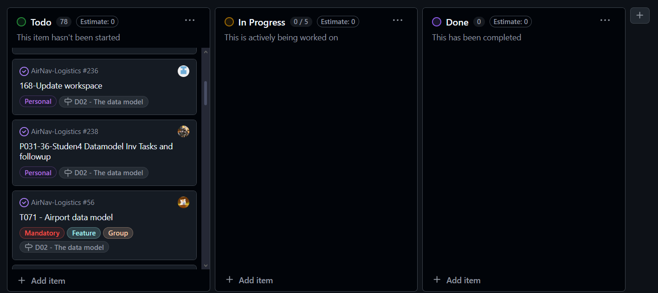

* **Midway Progress:** Screenshot displaying different task types across various lanes.

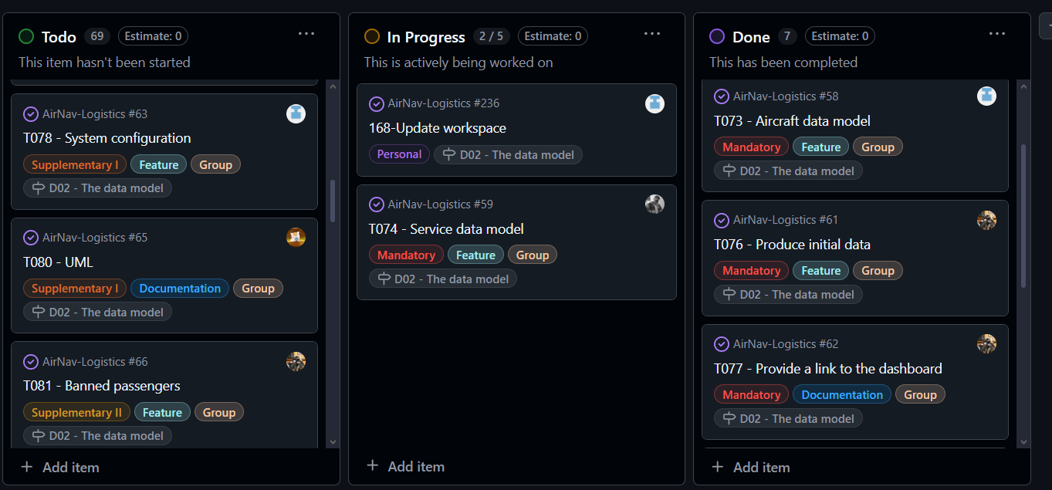

* **Completion:** Screenshot of the "Done" lane showing finalized tasks.

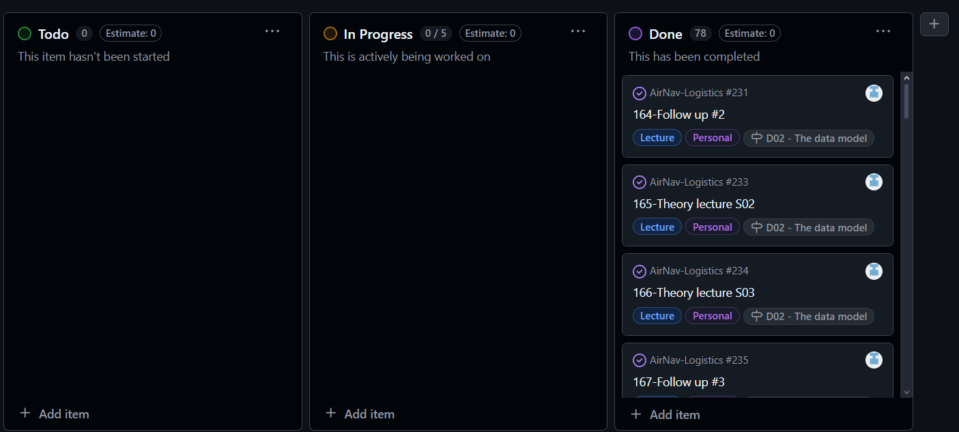

**Budget Estimation**

**JOSÉ**

|  |  |  |  |
| --- | --- | --- | --- |
| Role | Estimated Hours | Hourly Rate | Estimated Cost |
| Developer | 21 hours | €20/hr | €420 |
| Manager/Analyst | 0 hours | €30/hr | €0 |
| **Total Personnel Cost** | 21 **hours** | - | **€420** |
| Amortisation Cost | - | - | €20 |
| **Total Cost** | - | - | **€440** |

**NORA**

|  |  |  |  |
| --- | --- | --- | --- |
| Role | Estimated Hours | Hourly Rate | Estimated Cost |
| Developer | 27 hours | €20/hr | €540 |
| Manager/Analyst | 0 hours | €30/hr | €0 |
| **Total Personnel Cost** | 27 **hours** | - | **€540** |
| Amortisation Cost | - | - | €20 |
| **Total Cost** | - | - | **€560** |

|  |  |  |  |
| --- | --- | --- | --- |
| Role | Estimated Hours | Hourly Rate | Estimated Cost |
| Developer | 27.5 hours | €20/hr | €550 |
| Manager/Analyst | 0 hours | €30/hr | €0 |
| **Total Personnel Cost** | 27.5 **hours** | - | **€550** |
| Amortisation Cost | - | - | €20 |
| **Total Cost** | - | - | **€570** |

**NICOLÁS**

|  |  |  |  |
| --- | --- | --- | --- |
| Role | Estimated Hours | Hourly Rate | Estimated Cost |
| Developer | 22 hours | €20/hr | €440 |
| Manager/Analyst | 0 hours | €30/hr | €0 |
| **Total Personnel Cost** | **22 hours** | - | **€440** |
| Amortisation Cost | - | - | €20 |
| **Total Cost** | - | - | **€460** |

|  |  |  |  |
| --- | --- | --- | --- |
| Role | Estimated Hours | Hourly Rate | Estimated Cost |
| Developer | 33 hours | €20/hr | €660 |
| Manager/Analyst | 0 hours | €30/hr | €0 |
| **Total Personnel Cost** | **33 hours** | - | **€660** |
| Amortisation Cost | - | - | €20 |
| **Total Cost** | - | - | **€680** |

**LUCÍA**

|  |  |  |  |
| --- | --- | --- | --- |
| Role | Estimated Hours | Hourly Rate | Estimated Cost |
| Developer | 24.5 hours | €20/hr | €491.5 |
| Manager/Analyst | 0 hours | €30/hr | €0 |
| **Total Personnel Cost** | **24.5 hours** | - | **€491.5** |
| Amortisation Cost | - | - | €20.0 |
| **Total Cost** | - | - | **€511.5** |

|  |  |  |  |
| --- | --- | --- | --- |
| Role | Estimated Hours | Hourly Rate | Estimated Cost |
| Developer | 20 hours | €20/hr | €400 |
| Manager/Analyst | 0 hours | €30/hr | €0 |
| **Total Personnel Cost** | **20 hours** | - | **€400** |
| Amortisation Cost | - | - | €20.0 |
| **Total Cost** | - | - | **€420.5** |

**MANUEL JESÚS**

|  |  |  |  |
| --- | --- | --- | --- |
| Role | Estimated Hours | Hourly Rate | Estimated Cost |
| Developer | 19 hours | €20/hr | €380 |
| Manager/Analyst | 5 hours | €30/hr | €150 |
| **Total Personnel Cost** | **24 hours** | - | **€530** |
| Amortisation Cost | - | - | €20.0 |
| **Total Cost** | - | - | **€550** |

|  |  |  |  |
| --- | --- | --- | --- |
| Role | Estimated Hours | Hourly Rate | Estimated Cost |
| Developer | 21 hours | €20/hr | €420 |
| Manager/Analyst | 3.5 hours | €30/hr | €105 |
| **Total Personnel Cost** | **24.5 hours** | - | **€525** |
| Amortisation Cost | - | - | €20.0 |
| **Total Cost** | - | - | **€545** |

**Progress Chapter**

**Progress Records**

|  |  |  |  |
| --- | --- | --- | --- |
| Member | Performance Indicator | Good/Bad | Action Taken |
| Nora Peñaloza | Completed tasks on time | Good | Recognition |
| Nicolás Gómez | Completed tasks on time | Good | Recognition |
| Manuel Jesús Niza | Completed tasks on time | Good | Recognition |
| Jose Garcia de Tejada | Completed tasks on time | Good | Recognition |
| Lucía Campos | Completed tasks on time | Good | Recognition |

**Conflict Resolution**

No conflicts arose during the period of work

**Cost Comparison**

🡪José

|  |  |  |  |  |  |
| --- | --- | --- | --- | --- | --- |
| Role | Estimated Hours | Actual Hours | Hourly Rate | Estimated Cost | Actual Cost |
| Developer | 21 hours | 22 hours | €20/hr | €420 | €440 |
| Manager/Analyst | 0 hours | 0 hours | €30/hr | €0 | €0 |
| **Total Personnel Cost** | **21 hours** | **22 hours** | - | **€420** | **€440** |
| Amortisation Cost | - | - | - | €20 | €20 |
| **Total Cost** | - | - | - | **€420** | **€440** |

🡪Nora:

|  |  |  |  |  |  |
| --- | --- | --- | --- | --- | --- |
| Role | Estimated Hours | Actual Hours | Hourly Rate | Estimated Cost | Actual Cost |
| Developer | 27 hours | 25.8 hours | €20/hr | €540 | €516 |
| Manager/Analyst | 0 hours | 0 hours | €30/hr | €0 | €0 |
| **Total Personnel Cost** | **27 hours** | **25.8 hours** | - | **€540** | **€516** |
| Amortisation Cost | - | - | - | €20 | €20 |
| **Total Cost** | - | - | - | **€560** | **€536** |

|  |  |  |  |  |  |
| --- | --- | --- | --- | --- | --- |
| Role | Estimated Hours | Actual Hours | Hourly Rate | Estimated Cost | Actual Cost |
| Developer | 27.5 hours | 28.5 hours | €20/hr | €550 | €573.40 |
| Manager/Analyst | 0 hours | 0 hours | €30/hr | €0 | €0 |
| **Total Personnel Cost** | **27.5 hours** | **28.5 hours** | - | **€550** | **€573.40** |
| Amortisation Cost | - | - | - | €20 | €20 |
| **Total Cost** | - | - | - | **€570** | **€593.40** |

🡪Nicolás:

|  |  |  |  |  |  |
| --- | --- | --- | --- | --- | --- |
| Role | Estimated Hours | Actual Hours | Hourly Rate | Estimated Cost | Actual Cost |
| Developer | 22 hours | 24 hours | €20/hr | €440 | €480 |
| Manager/Analyst | 0 hours | 0 hours | €30/hr | €0 | €0 |
| **Total Personnel Cost** | **22 hours** | **24 hours** | - | **€440** | **€480** |
| Amortisation Cost | - | - | - | €20 | €20 |
| **Total Cost** | - | - | - | **€460** | **€500** |

|  |  |  |  |  |  |
| --- | --- | --- | --- | --- | --- |
| Role | Estimated Hours | Actual Hours | Hourly Rate | Estimated Cost | Actual Cost |
| Developer | 33 hours | 37.5 hours | €20/hr | €660 | €750 |
| Manager/Analyst | 0 hours | 0 hours | €30/hr | €0 | €0 |
| **Total Personnel Cost** | **33 hours** | **37.5 hours** | - | **€660** | **€750** |
| Amortisation Cost | - | - | - | €20 | €20 |
| **Total Cost** | - | - | - | **€680** | **€770** |

🡪Lucía:

|  |  |  |  |  |  |
| --- | --- | --- | --- | --- | --- |
| Role | Estimated Hours | Actual Hours | Hourly Rate | Estimated Cost | Actual Cost |
| Developer | 24.5 hours | 28 hours | €20/hr | €491.5 | €560 |
| Manager/Analyst | 0 hours | 0 hours | €30/hr | €0 | €0 |
| **Total Personnel Cost** | **24.5 hours** | **28 hours** | - | **€491.5** | **€560** |
| Amortisation Cost | - | - | - | €20 | €20 |
| **Total Cost** | - | - | - | **€511.5** | **€580** |

|  |  |  |  |  |  |
| --- | --- | --- | --- | --- | --- |
| Role | Estimated Hours | Actual Hours | Hourly Rate | Estimated Cost | Actual Cost |
| Developer | 20 hours | 26.5 hours | €20/hr | €400 | €530 |
| Manager/Analyst | 0 hours | 0 hours | €30/hr | €0 | €0 |
| **Total Personnel Cost** | **20 hours** | **26.5 hours** | - | **€400** | **€530** |
| Amortisation Cost | - | - | - | €20 | €20 |
| **Total Cost** | - | - | - | **€420** | **€550** |

🡪Manuel Jesús:

|  |  |  |  |  |  |
| --- | --- | --- | --- | --- | --- |
| Role | Estimated Hours | Actual Hours | Hourly Rate | Estimated Cost | Actual Cost |
| Developer | 19 hours | 18.42 hours | €20/hr | €380 | €368.40 |
| Manager/Analyst | 5 hours | 9.25 hours | €30/hr | €150 | €277.50 |
| **Total Personnel Cost** | **24 hours** | **28 hours** | - | **€530** | **€645.9** |
| Amortisation Cost | - | - | - | €20.0 | €20 |
| **Total Cost** | - | - | - | **€550** | **€665.9** |

|  |  |  |  |  |  |
| --- | --- | --- | --- | --- | --- |
| Role | Estimated Hours | Actual Hours | Hourly Rate | Estimated Cost | Actual Cost |
| Developer | 21 hours | 22 hours | €20/hr | €420 | €440 |
| Manager/Analyst | 3.5 hours | 4 hours | €30/hr | €105 | €120 |
| **Total Personnel Cost** | **24.5 hours** | **26 hours** | - | **€525** | **€560** |
| Amortisation Cost | - | - | - | €20.0 | €20 |
| **Total Cost** | - | - | - | **€545** | **€580** |

**Conclusions**

This report has documented the planning and execution of the project deliverable. The tasks were successfully completed with minor discrepancies in planned vs. actual time. Budget estimations were close to actual expenses, with minor deviations due to increased workload. Collaboration and adherence to the working methodology ensured the project’s success. Lessons learned include the importance of precise task estimations and proactive conflict resolution.

**Bibliography**

Intentionally blank.